**MongoDB Task:**

For the following question write the corresponding MongoDB queries

1. Find all the information about each products

db.data.find({});

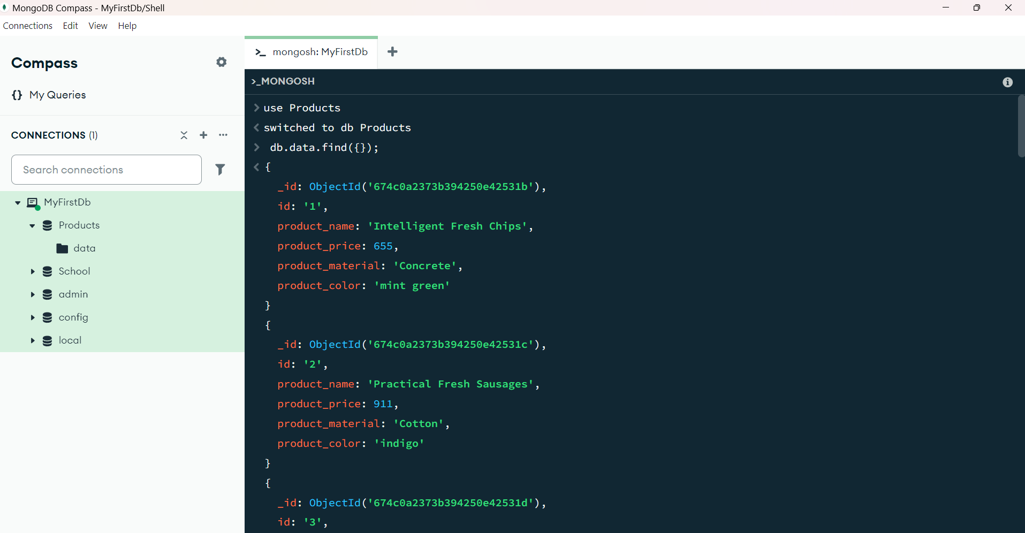

1. Find the product price which are between 400 to 800

db.data.find({

product_price: { $gt: 400, $lt: 800 }

});

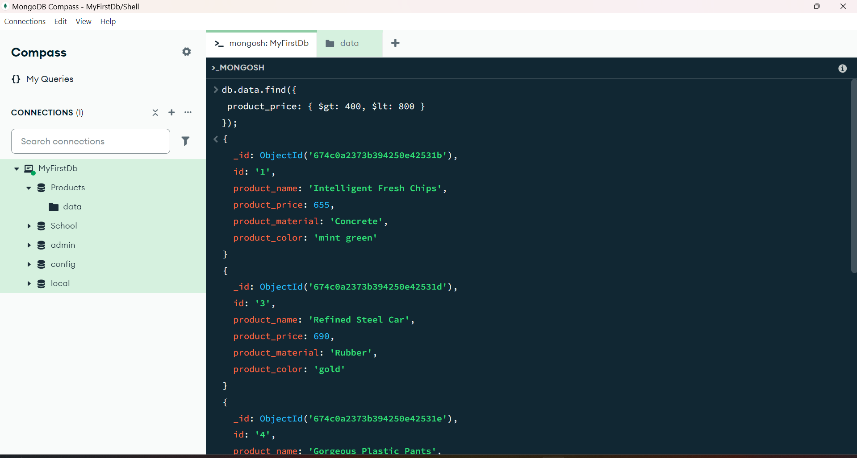

1. Find the product price which are not between 400 to 600

db.data.find({ price: { $not: { $gte: 400, $lte: 600 } } });

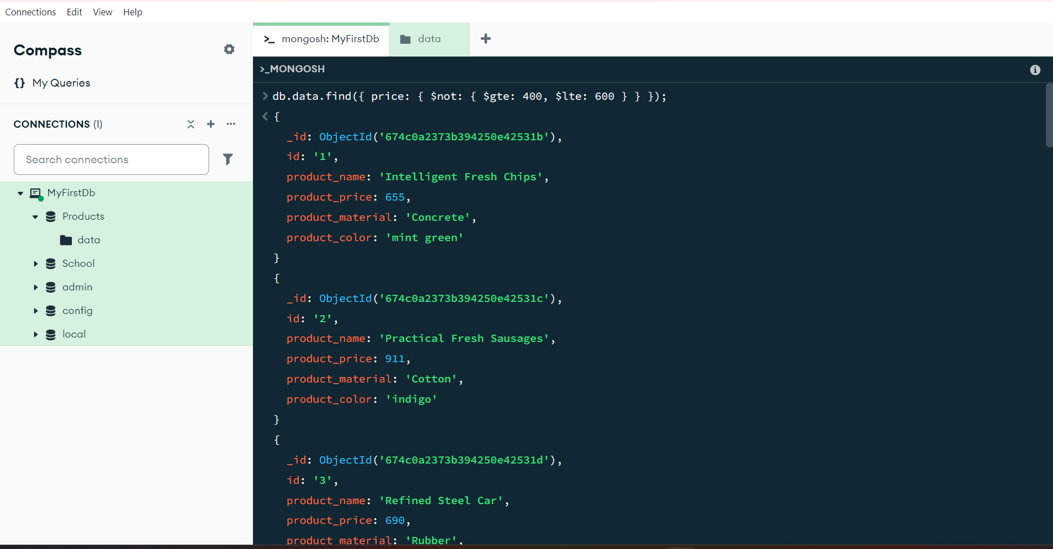

1. List the four product which are greater than 500 in price

db.data.find({**product_price:**{ $gt: 500 } }).limit(4)

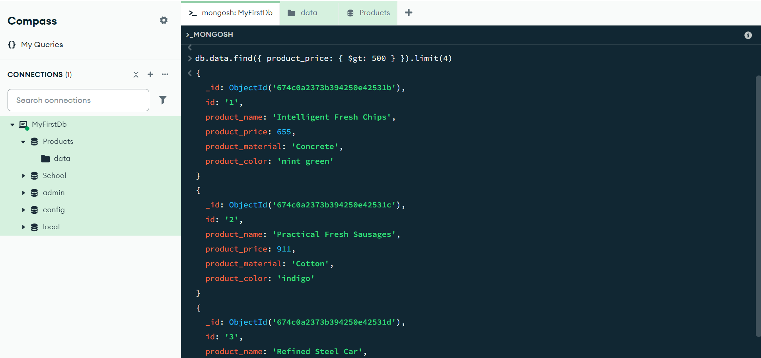

1. Find the product name and product material of each products

db.data.find({}, {

product_name: 1,

product_material: 1,

_id: 0

});

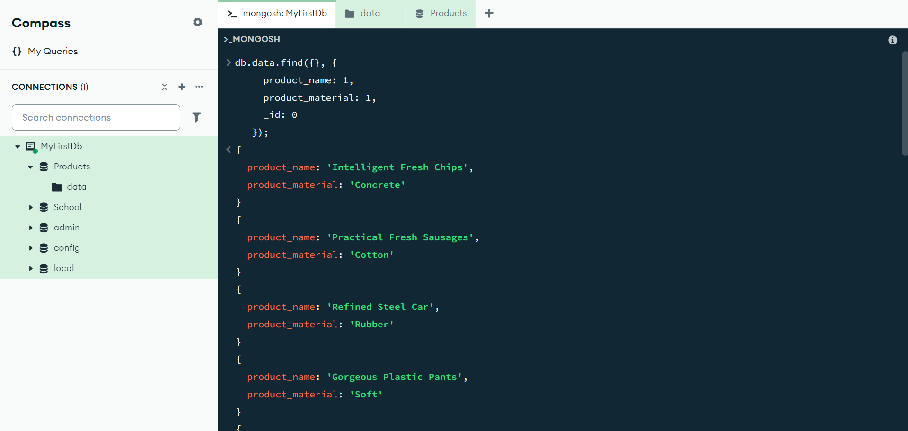

1. Find the product with a row id of 10

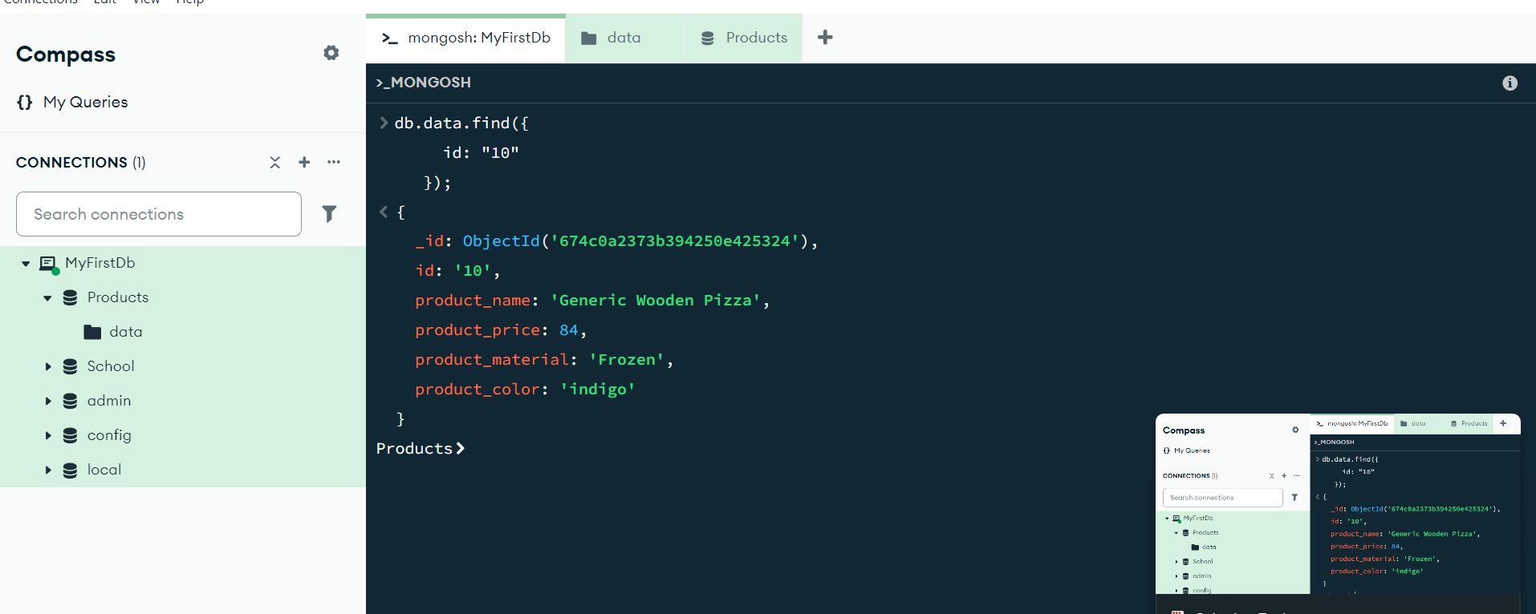

1. Find only the product name and product material

db.data.find({}, {

product_name: 1,

product_material: 1,

_id: 0

});

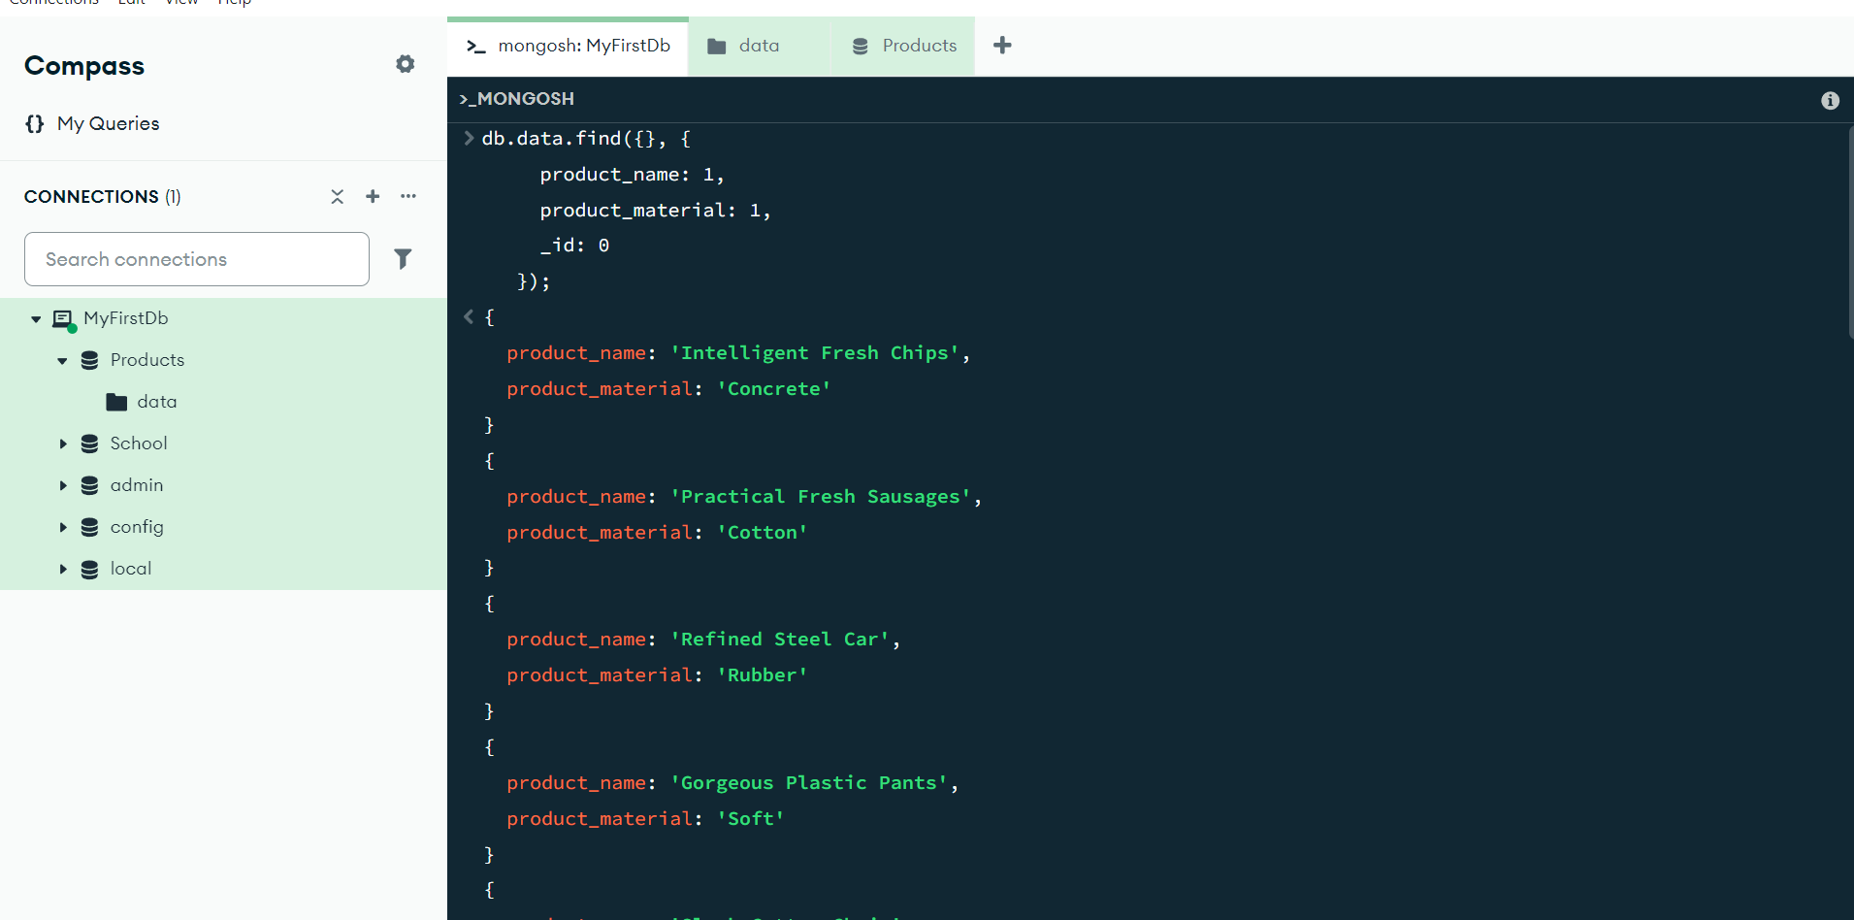

1. Find all products which contain the value of soft in product material

db.data.find({ product_material: /soft/i})

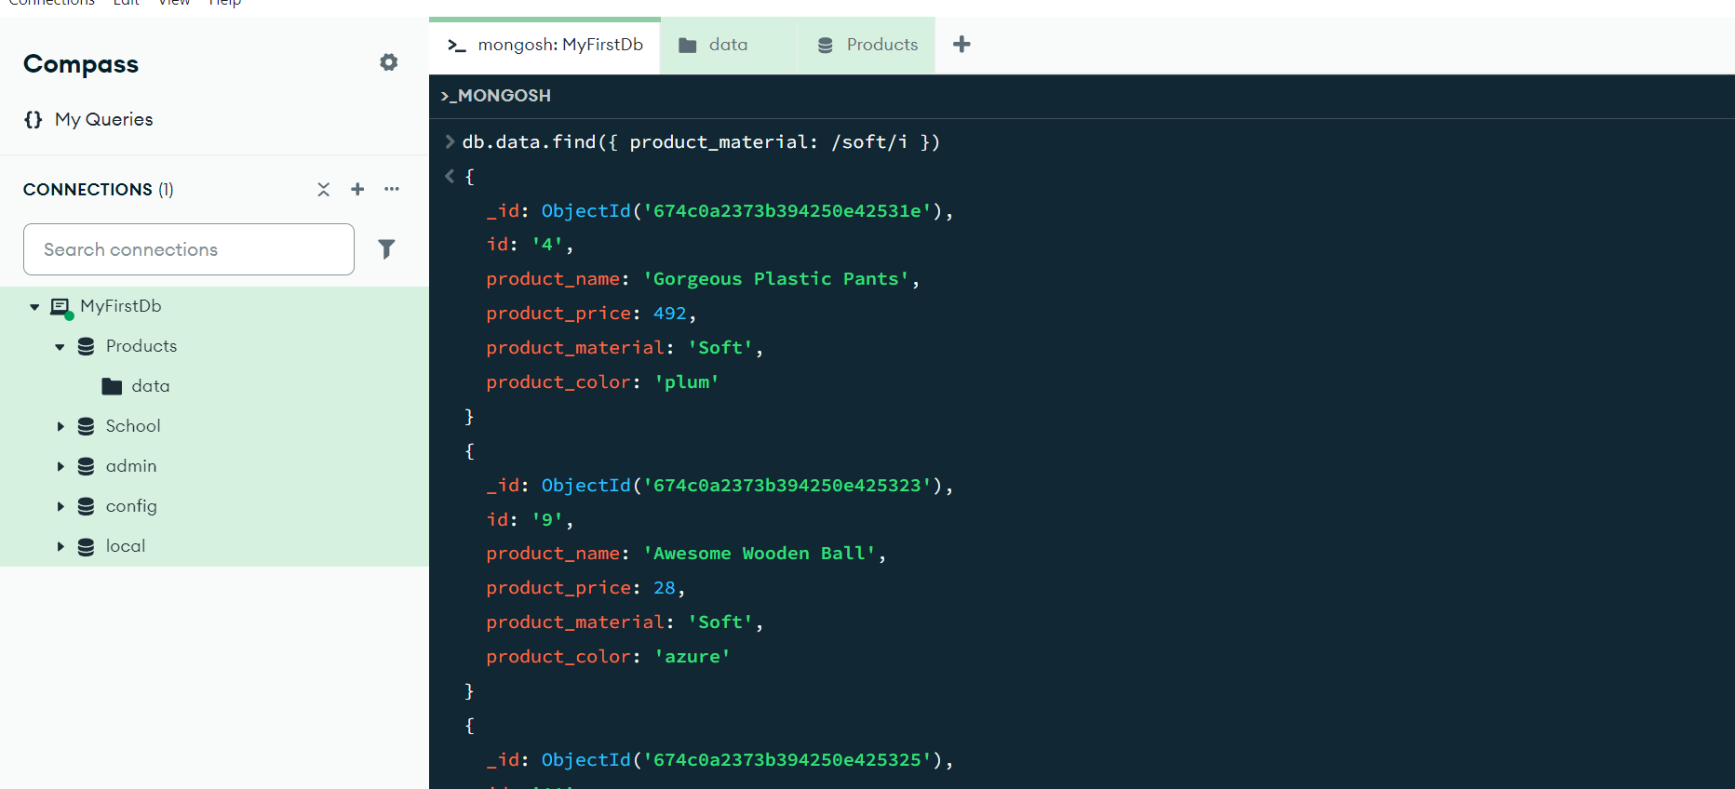

1. Find products which contain product color indigo  and product price 492.00

db.data.find({

$or: [

{ product_color: "indigo" },

{ product_price: 492 }

]

});

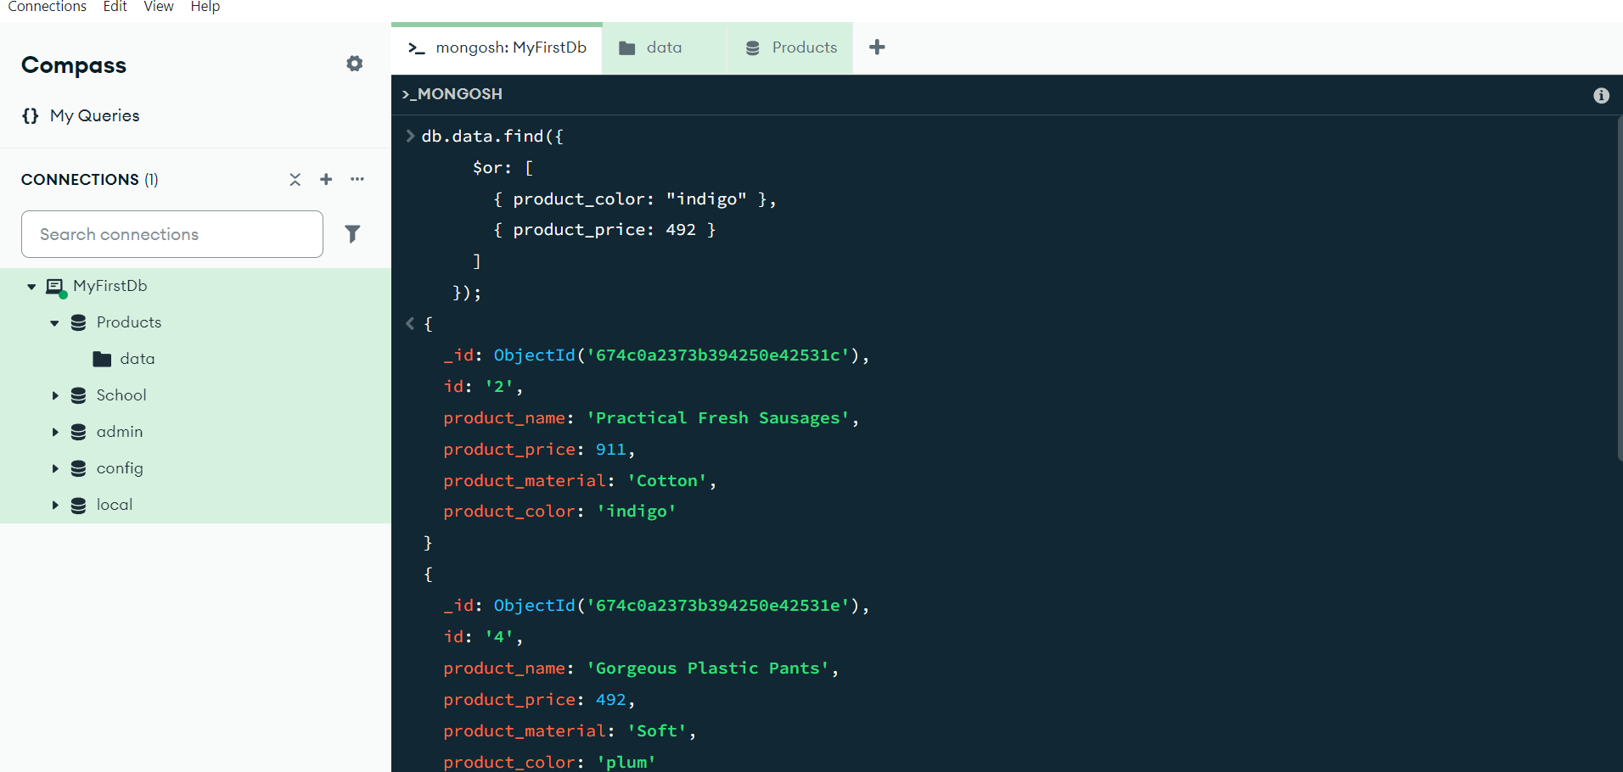

1. Delete the products which product price value are 28

